NAME: NAVODITAA A.R
ROLL NO: 241901071

13. THREAT INTELLIGENCE FOR SOC
DATE: 15/04/2026
Aim:To learn how to utilise Threat Intelligence to improve the Security Operations pipeline.
Procedure:
- Log into TryHackMe and open the Threat Intelligence for SOC room.
- Study the concept and importance of threat intelligence in SOC operations.
- Understand types of intelligence: strategic, tactical, and operational.
- Explore sources such as Indicators of Compromise (IOCs) and threat feeds.
- Learn how intelligence improves detection and response workflows.
- Complete the tasks and answer the questions in the room.
- Review the summary and confirm completion.
Tasks:
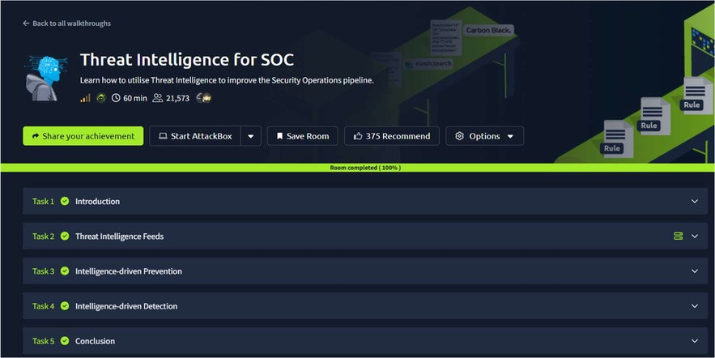
TASK 1 - Introduction
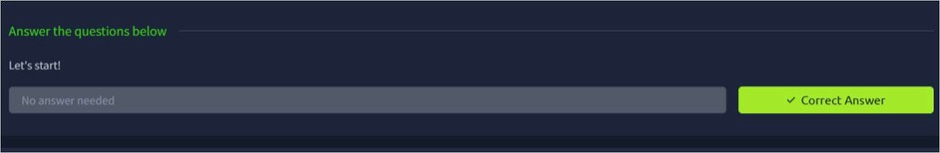

TASK 2 – Threat Intelligence Feeds
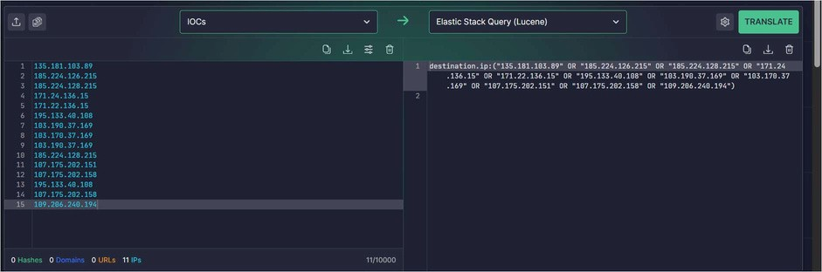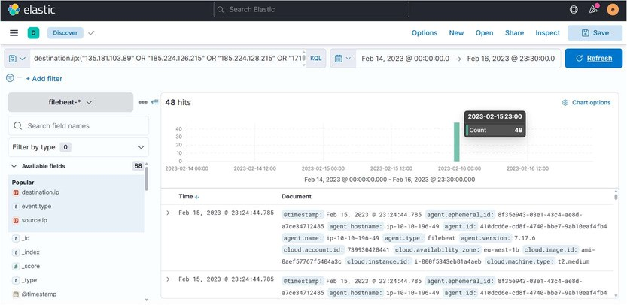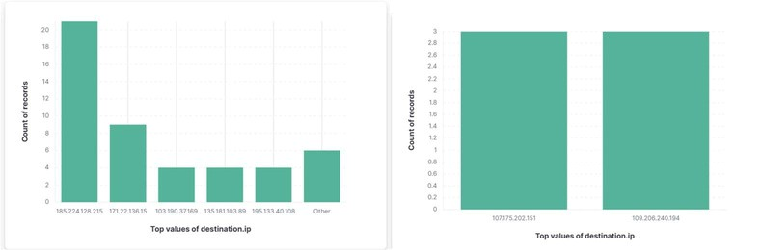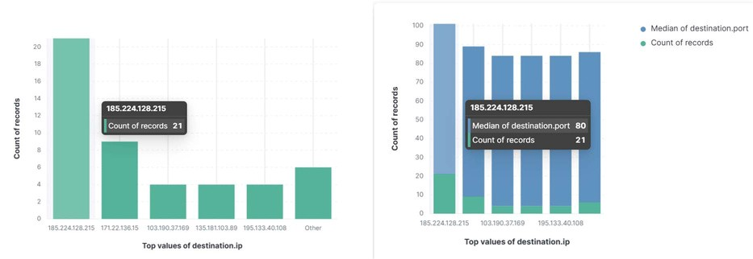

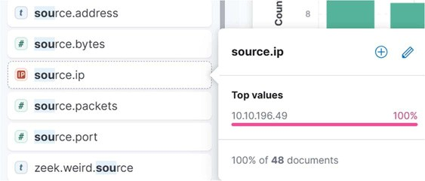
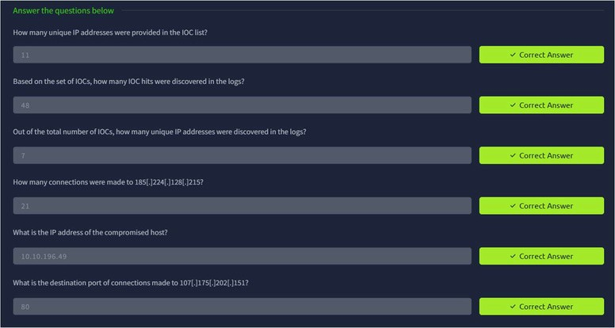
TASK 3 – Intelligence Driven Prevention
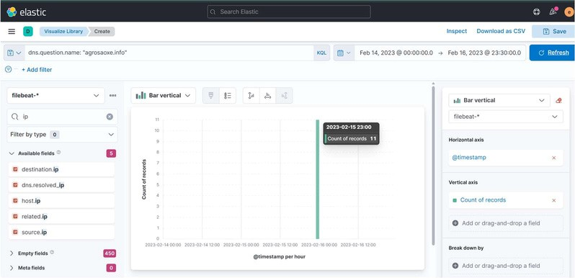
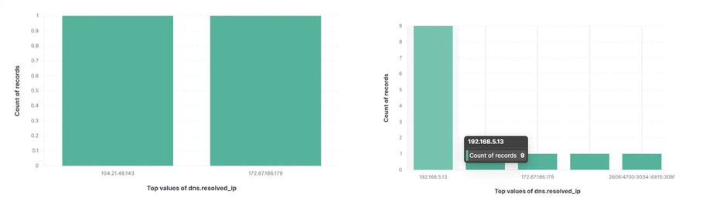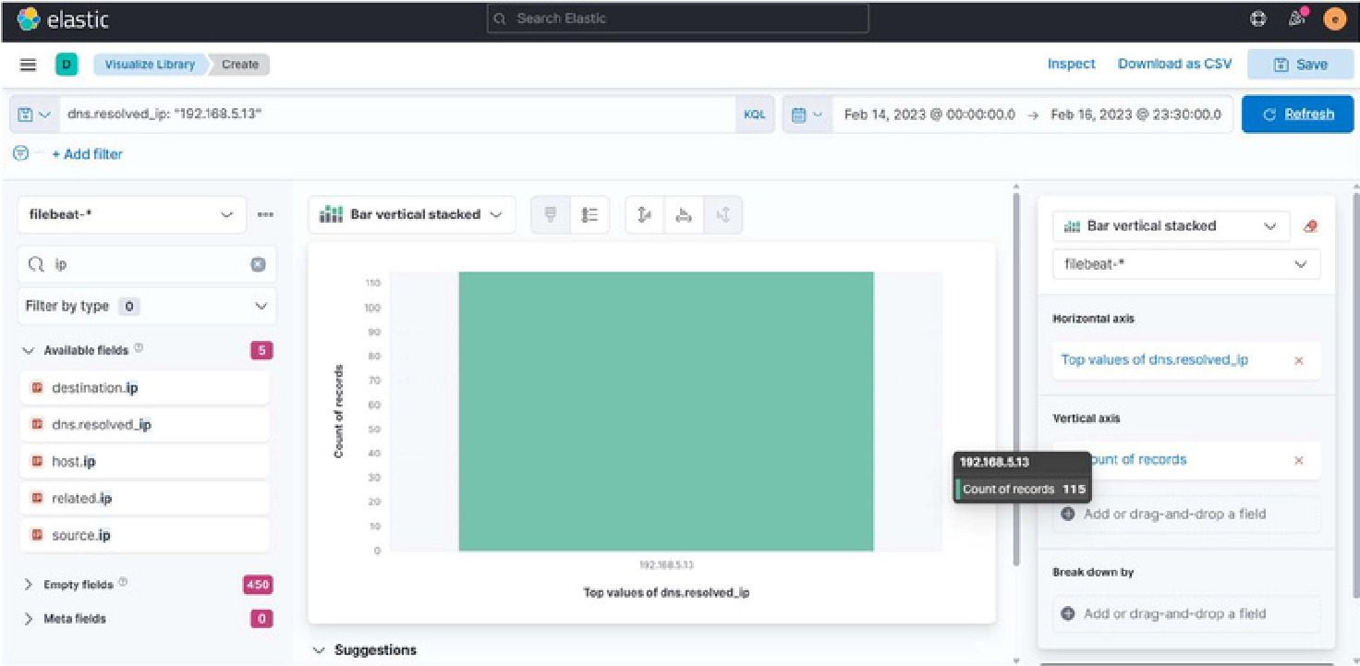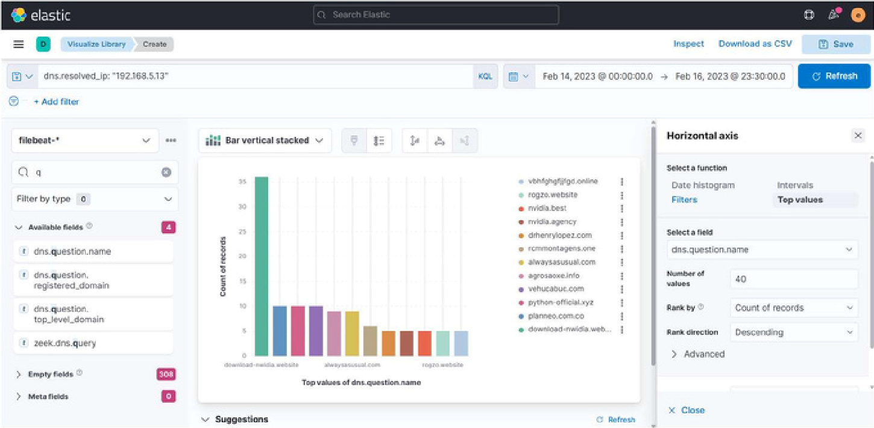
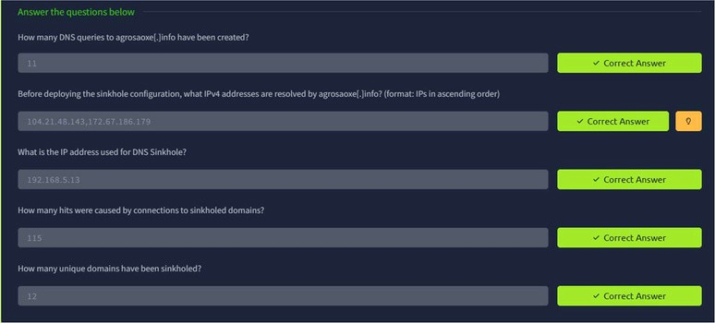

TASK 4 – Intelligence Driven Detection
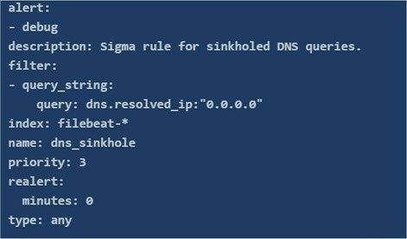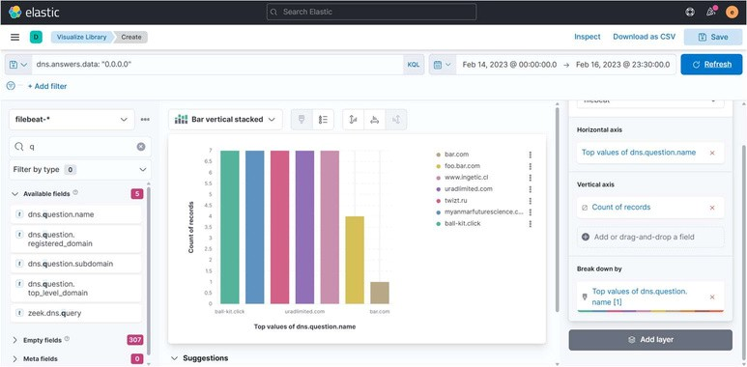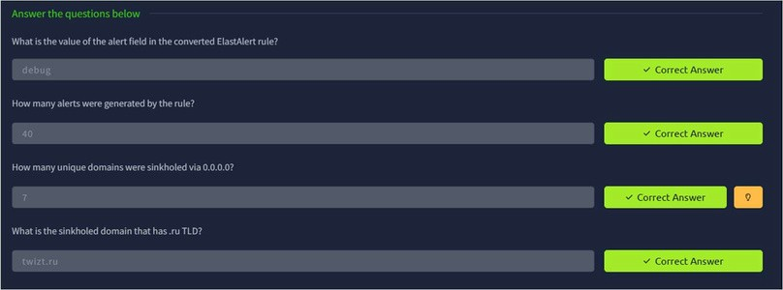
TASK 5 - Conclusion
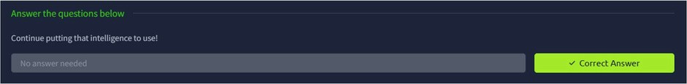
Result:
Thus the TryHackMe room “ Threat Intelligence for SOC” was completed successfully.

